Ringmer Neighbourhood Plan Review– Community Survey

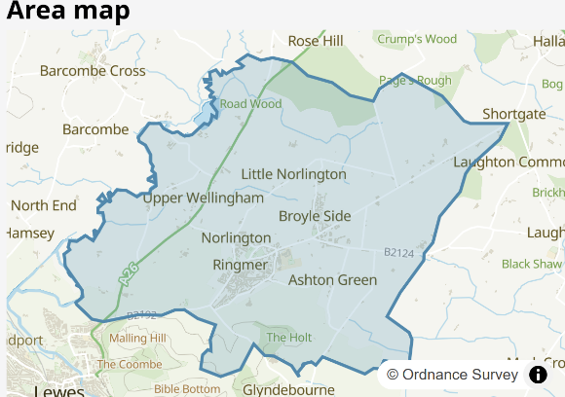
What’s happening?
Ringmer Parish Council is preparing a Neighbourhood Plan Review for our parish. The Ringmer Neighbourhood Plan is a document that contains planning policies that are used to help determine planning applications for development within Ringmer Parish. It sits alongside the Local Plans for Lewes District Council and, for the southern part of the parish, the South Downs National Park Authority.
Why are we doing this?
Our current Neighbourhood Plan was adopted in 2016 and we want to review it to make sure that it is up-to-date and relevant.
We are not intending to allocate sites for development (for example for housing or other uses) in the Neighbourhood Plan Review. This is because Lewes District Council is doing this in their update to their own Local Plan. Instead, our document will focus on setting out information to influence development – such as the sorts of housing that might be built, the design of development, and what kind of community facilities are needed. We anticipate that the Lewes Local Plan will identify development sites in Ringmer Parish. Developers will be expected to make financial contributions towards local infrastructure and the Neighbourhood Plan Review will give us an opportunity to say what is most important to us.
How you can get involved
This short survey is one way that we will be gathering information over the coming months about your views on what we should be focusing on in the Review. The questions are largely open-ended, giving you an opportunity to share fully your views on a range of topics. Some have a series of questions to inspire your responses.
You can complete all the questions or some of the questions. You are also welcome to complete the survey individually or jointly, for instance, with other members of your family. If someone else in your household wishes to respond separately, that is also welcomed.
If you prefer to complete the survey online please visit: https://www.surveymonkey.com/r/Ringmer1
You can visit our website here, which also contains our existing Neighbourhood Plan: You can view the current Plan here: https://ringmerparishcouncil.gov.uk/your-council/neighbourhood-plan.

- What do you like most about living in Ringmer?

- What could be improved?

- If you have moved to the parish within the last four years, please tell us what attracted you to move here. Has it met your expectations? Please tell us why.

- Types of development – Would you support any of the following and, if so, where?
- More housing provision
- More retail provision
- More employment/commercial land provision
- Renewable energy schemes (e.g. solar, wind farms etc.)
- Other (please provide details)

- Homes - What type of homes do you think are needed in the parish? For instance homes suited to young families or couples, for those wishing to downsize, for those with additional needs, for older people (e.g. care homes, independent living, bungalows), more affordable homes, homes to rent or to buy. Are there any other requirements in relation to housing that you think we should be prioritising?

- Design - We have an opportunity to influence the design of any new development. How would you describe the character of Ringmer in terms of, for example, typical materials used, features of buildings, styles of architecture that fit in well locally.

- Local heritage - Are there any buildings or other structures that are important to you and which you think we should be protecting?

- The natural environment – We have an opportunity to protect valued green spaces locally. The Parish Council looks after Fingerpost Field, the Village Green, Anchor Field and the Almond Field. Are there other areas of green space in the parish that are important to you?

- Wildlife and habitats – Are there areas of the parish that you think could be improved for wildlife (animals / plants)?

- Jobs – What sort of employment opportunities do you think we need to support and is any additional infrastructure needed to do this (e.g. faster broadband, shared workspace, additional retail provision etc.)?

- Tourism - Should we be promoting the parish to visitors? What are the two most important developments required within the parish as regards to tourism?

- Public spaces – What do you consider to be the important public spaces here and what you do use them for? Should more space be provided?

- Getting around – Whilst we have limited influence over the provision and improvement of roads (which is the responsibility of East Sussex County Council), we can encourage more walking, cycling and horse-riding locally. Are there areas of the rights of way network/ local pavements/local roads that could be better connected or improved?

- Getting around – When accessing local shops and other facilities, how do you normally get there, for instance by car, on foot, by bike, using the bus etc. Please provide details.

- Walking and Cycling – What could we do to improve provision for walking, cycling and/or horse-riding locally?

- Public transport – How could public transport be improved?

- Local facilities – In terms of actual facilities, are there any community facilities that you think we need or existing ones that should be improved? Do we have adequate facilities for children and teenagers? What about older people? What else could be provided?

- Flooding - Have you experienced issues related to flooding? Please provide details including to location, the cause and when it happened.

- Is there anything else you’d like to tell us?

About you

- Please tell us your location:

- Ringmer
- Broyleside
- Elsewhere in the parish
- Outside the parish

- Please tell us which age bracket you are in:

- Under 18
- 18-24
- 25-34
- 35-44
- 45-54
- 55-64
- 65+

- Would you like to:

- Sign up to emails about progress on the neighbourhood plan
- Join the Steering Group
- Join a Working Group on a particular topic (please tell us below what topics interest you)

- If yes, please provide your contact details:

Name: Email/ address:

Please note that we will only contact you in relation to the Ringmer Neighbourhood Plan and let us know if you wish to be removed from the contact list.

Thank you for completing the survey. Please return to: Ringmer Parish Council, Old School Close
Ringmer, East Sussex, BN8 5RA (Access via Harrisons Lane then Greater Paddock) Tel: 01273 813 242

